# A 300 – 600 set square of longest side 100 mm long, is in VP and 300 inclined to HP while it’s surface is 450 inclined to VP. Draw it’s projections

## a’ a’1

c’

c’1

a’1

c’1

## b’

b’1

X b 450 a1

a

## c

* 1. c1

## c

300

b’1

b1 Y

1. A circle of 40 mm diameter is resting on HP on end A of its diameter AC which is 40° inclined to HP and 45° inclined to VP. Draw its projections.

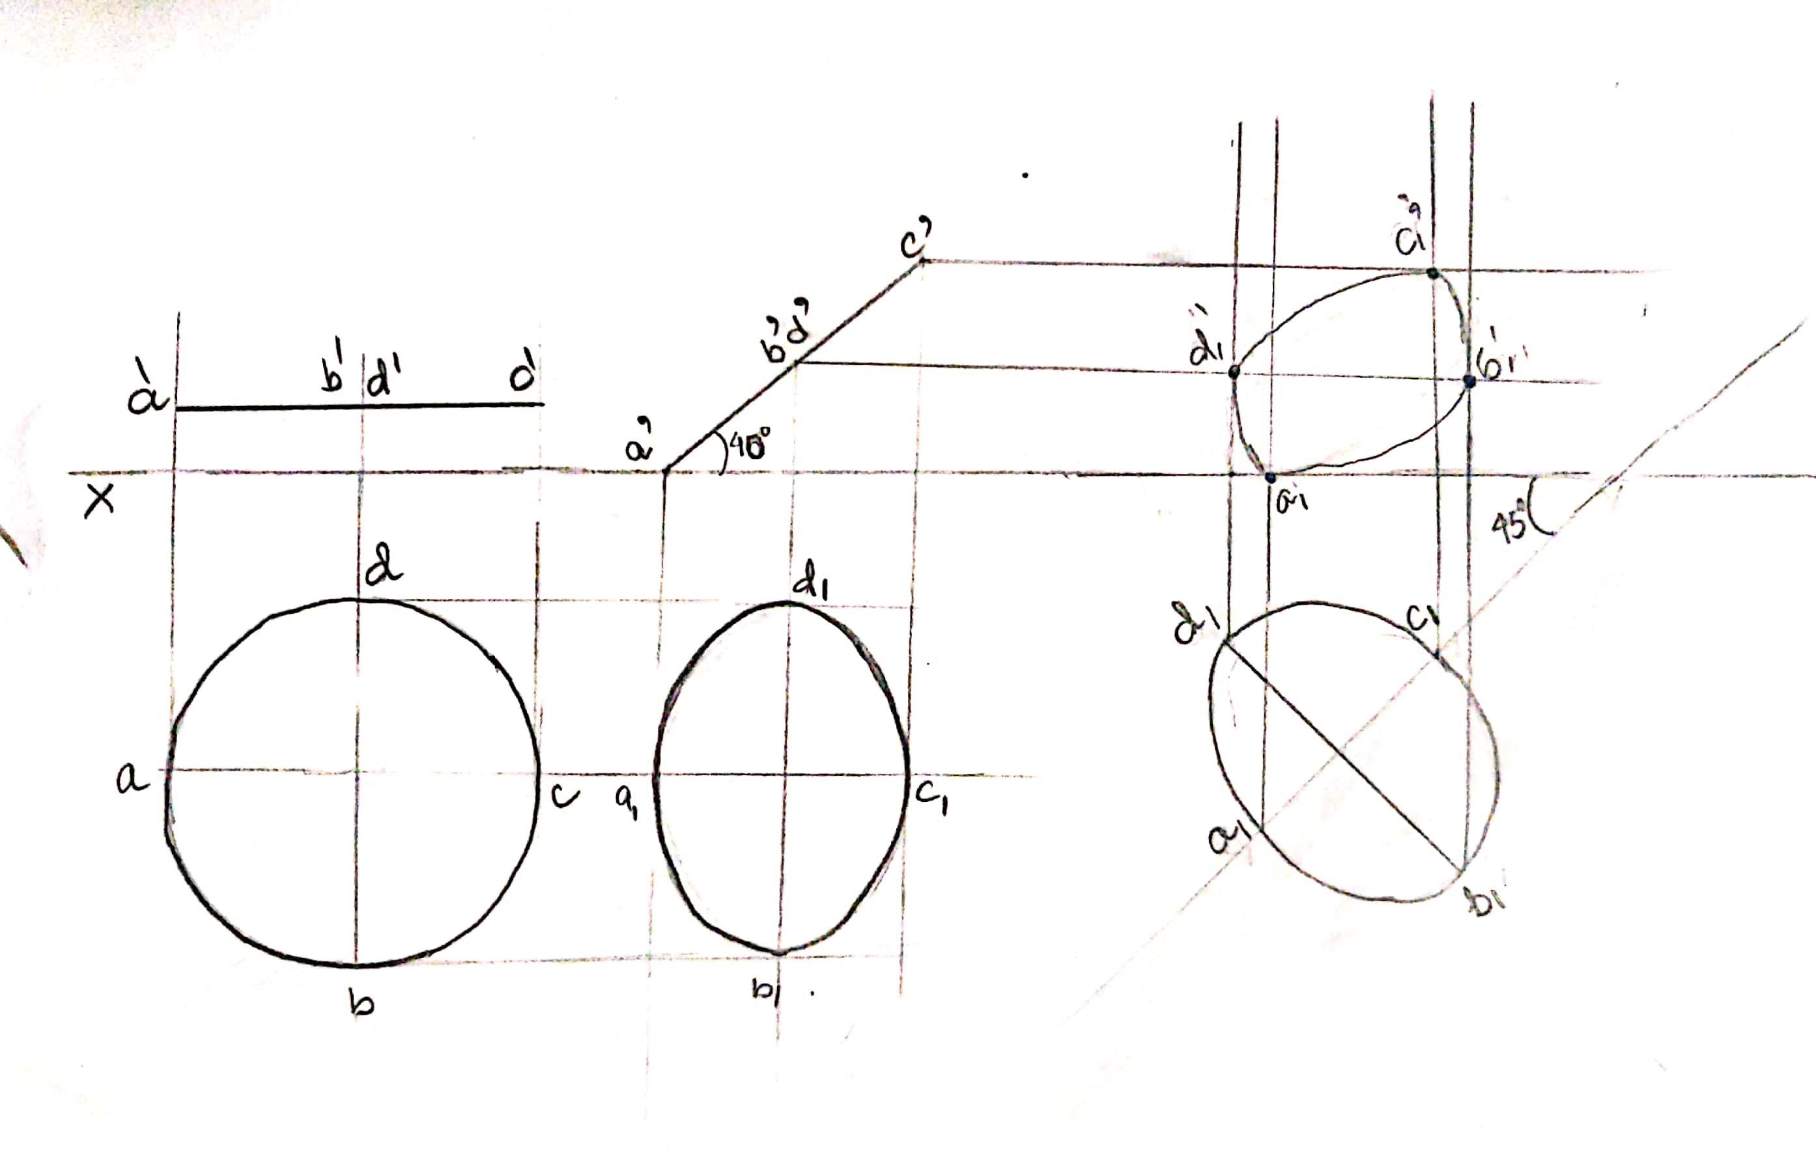

1. A rectangular lamina of 40mm and 20mm rests on one of the corners on the HP. The diagonal AC through that corner makes 30o to the VP. The two sides containing this corner make equal inclination with HP. The surface of the lamina makes 50o to the HP. Draw the TV and FV of the lamina.

Note: Here, while drawing the initial top view, side AB can have any angle with XY except 90 degree.

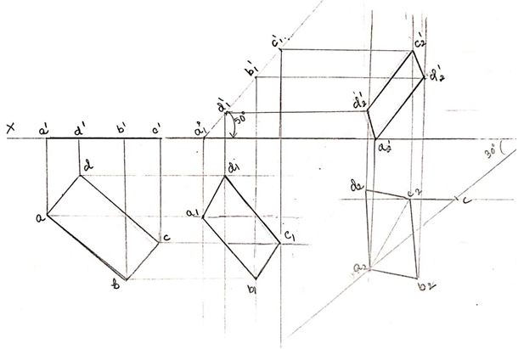

1. A regular pentagon of 30 mm sides is resting on HP on one of its sides with its surface 45° inclined to HP. Draw its projections when the side in HP makes 40° angle with VP.

